Project Design Phase
Problem – Solution Fit Template

Date | 15 February 2026
Team ID | LTVIP2026TMIDS24884
Project Name | Hear Disease Analysis
Maximum Marks | 2 Marks

Problem – Solution Fit Template:
Heart disease is one of the leading causes of death worldwide. Many patients are unaware of their risk factors such as high cholesterol, obesity, smoking habits, diabetes, and blood pressure. Hospitals and health authorities often struggle to analyze large health datasets efficiently to identify high-risk groups and patterns.
Purpose:
The Heart Disease Analysis System provides:
- Interactive dashboard using Tableau
- Data-driven insights from heart disease dataset
- Risk factor visualization (Age, BMI, Smoking, Diabetes, Cholesterol)
- Secure login system
- Filter-based health trend analysis
Template:
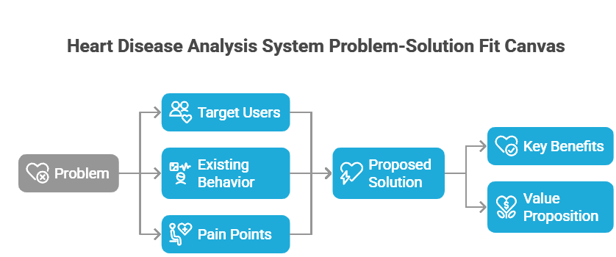

References:
- https://www.ideahackers.network/problem-solution-fit-canvas/
- https://dev.mysql.com/doc/

